Oxidation Numbers

Elements have an oxidation number of 0.

Each atom in a compound has an oxidation number, and overall compounds must have an oxidation number of 0, unless they are an ion.

Generally, the oxidation number is the same as ionic charge.

Special cases:
- H in metal hydrides (NaH, CaH₂) is -1
- O in peroxides is -1
- O bonded to F is +2
- Chorine has many oxidation numbers

In H₂SO₄:
H₂ = +2
O₄ = 4(-2) = 8
2 – 8 + S = 0, S = 8-2 = 6

In PO₄³⁻:
O = 4(-2)
P + 4(-2) = -3, P = -3-4(-2) = 5

Redox

This is where a reaction contains both a reduction and an oxidation.

Reduction is gain of electriof, oxidation is loss of electrons.

E.g.:
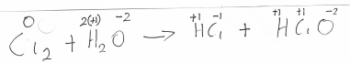
Here, Chlorine is reduced from 0 to -1 in the HCl, but also oxidised from 0 to +1 in the HclO.

